
unit 6 project
Factors determining rates of reaction

by:
meelad hamdard
PEARSON BTEC LEVEL 3 EXTENDED NATIONAL DIPLOMCA IN APPLIED SCIENCE (NQF)

Contents
Introduction of the investigative project 3
Assignment A – project research 3
Introduction 3
Literature search and review 3
Collision theory 4
Factors affecting the rate of reaction 4
Nature of reaction 5
Change in concentration 5
Pressure factor 6
Temperature 6
Electromagnetic radiation 8
Presence of catalyst 8
The surface area of reactants 9
Rate of determining steps 9
Methods 10
Method 1 – using temperature to determine the rate of reaction 10
Method 2 – using concentration to determine the rate of reaction 10
Method 3 – using different concentration to determine the rates of reaction 10
Method 3 – using catalysts to determine the rate of reaction 10
Review of research 11
General conclusion 11
Conclusion 12
Investigative project proposal 12
Hypothesis 12
Null hypothesis 12
Aim and objectives 13
Potential limitations 13
Assignment B – Project investigation plan 15
Schedule 15
Plan 15
Aim 15
Objectives 15
Hypothesis 15
Null hypothesis 15
Variables 15
Apparatus 15
Method 16
Contingency planning 17
Apparatus 17
Method 17
Result table 18
Health and safety 18
Risk assessment 18
Ethical considerations 19
Unit 6 – investigative project, Assignment C and D 20
Project implementation and review 20
Collection, analysis and presentation of the results 20
Report of the investigative project 21
Title 21
Abstract 21
Introduction 21
Method 21
Results 21
Graphs 23
Uncertainties 25
Accuracy 25
Discussion 25
Conclusions 26
Scientific evaluation 26
Skills developed within project work 27
Reference 28

Introduction of the investigative project
I have decided to investigate the ‘Factors determining the rates of reaction’ as a project work for this unit. This unit is separated to four different assignments (A, B and C, D). Assignment A will be a project research, assignment B will be plan for a practical investigation to take place. Assignment C and D is a part of the same assignment as the C part I will carry out a practical investigation and the D part I will do a investigation report and finalise it. The topic I have chosen to investigate is an area in chemistry science that has great influence in many industrial companies. I will carry out a literature research on this project, plan an investigation and carry it out using the research and the information taken from the researches done as mention earlier.

Assignment A – project research
In this assignment I will carry out a literature search and review into a chosen scientific area. I will also produce an appropriate project proposal for an investigative proposal to include hypothesis. I will then analyse a literature search and discuss its relevance to inform the investigative project proposal. Then, I will produce a project proposal for a scientific investigation to include hypothesis and potential limitations. Finally, I will evaluate the different methods of investigation that is considered for the investigative project proposal and justifying the hypothesis chosen.

Introduction
This topic will include a research of the factors determining the rates of reaction and review of it as well. The reason to why this topic was chosen Is it easy to follow up with and it found me great interest as I managed to understand the importance of it in industries and different facilities. The topic will include a deep research of the collision theory and the factors that affects the rate of reaction such as temperature, concentration, catalysts, pressure, surface area and other.

Literature search and review
It is so that the rate of reaction has a great impact on the industrial making of products such as medicine for example. The aim of an industrial chemistry is to try to maximise the yield and get as close as possible to 100 per cent yield, but it is important to know that in producing any chemical economically, the yield from a reaction is just one of the factors involved. Another very important factor is the rate of reaction, there is no point having a yield of iron in a process that is very slow. A very simple definition would be that; the rate of reaction is the amount of substance formed per unit of time.
The rate can also be in moles per second, for industry it is more appropriate to give the rate as the mass of substance such as kilograms or tonnes that is formed per unit of time. The reactions can also be very fast and uncontrolled such as gas explosion, but they can also be extremely slow such as in the rusting of iron. An industrial chemist has the task to be able to control the rate of reaction which means they can either slow it down or speed it up. In industry scale the rate of reactions needs to be increased as a certain amount of product needs to be formed during a certain period.

Collision theory
According to the collision theory is that in a chemical reaction, the reactant particles will only be able to react with each other when they collide into another. It is so that when the molecules collide the bonds between their atoms can break and new bonds can be formed to make new molecules. In gases and liquids there are millions of collisions that take place every second as the molecules in there are moving constantly. However, only a small number of these collisions lead to a formed product. A successful collision would be considered only when it breaks the existing bonds and for that enough energy is required for them to be able to that, it is called the activation energy. In simpler definition it would be that an increase of collisions per second or increase in the energy of the particles that collide it will increase the rate of reaction. Therefore, the factors that can affect that would be the temperature, concentration, pressure, surface area and catalyst. An increase in the temperature will increase the number of collisions as there will be more energy in the collisions, more collisions will have the activation energy that will then result in an increase in the rate of reaction. Similar theory can be used for the other factors.
http://www.bbc.co.uk/schools/gcsebitesize/science/add_ocr_pre_2011/chemical_synthesis/ratereactionrev3.shtml
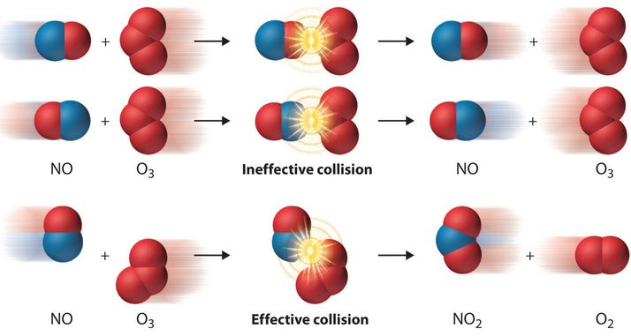
http://thescienceclassroom.org/chemistry-lessons/kinetics/collision-theory/

Factors affecting the rate of reaction
The factors that affects the rate of reaction are there to be able to increase or decrease the rate of a chemical reaction. The following factors has a great impact on the rate of reaction and are the cause for the change in rate of a chemical reaction.
- Nature of the reaction
- Change in concentration
- Pressure factor
- Temperature
- Solvent
- Electromagnetic radiation
- The intensity of light
- Presence of catalyst
- Surface area of reactants

Nature of reaction
The type and the nature of the reaction are the two dependants that decide the rate of reaction. It is so that some reactions are naturally slower than others while some reactions are faster. The factors that has a great influence in the rate of reaction are the physical state of reactants, complexity of reaction, number of reactants and other few factors. It is known that the rate of reaction is normally slower in liquids when it is compared to gases and slower in solids when compared to liquids. The size of the reactants also has a great importance and matters a lot, it can simply be said that the smaller size of reactant, the faster reaction.
The rate of reaction will depend on the nature of bonding in the reactant, usually the ionic compounds react faster than covalent compounds. The reactions between ionic compounds in water takes place very quickly as they involve only exchange of ions, which were already separated in aqueous solutions during their dissolution. An example of that can be the AgCl that is precipitated out very quickly when AgNO₃ solution is added to NaCl solution.
AgNO_{3 (aq)} + NaCl _{(aq)} AgCl _{(s)} + NaNO_{3 (aq)}
This reaction only involved the exchange of ions as shown below and occurs very fast.
Ag⁺ _{(aq)} + NO⁻_{3 (aq)} + Na⁺_{(aq)} + Cl⁻_{(aq)} AgCl _{(s)} + Na⁺_{(aq)} + NO⁻_{3 (aq)}
In the other hand, the reactions between covalent compounds take place very slowly as they require energy for the cleavage of the existing bonds. An example of that is the esterification of acetic acid that occurs extremely slowly since the breaking of the bond has a great requirement of energy.
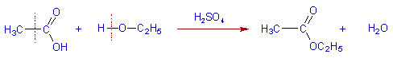
http://www.adichemistry.com/physical/kinetics/factors/factors-affecting-rate-reaction.html#CONCENTRATION-OF-REACTANTS

Change in concentration
If the collision theory was to be followed, the rate of reaction would then increase with the concentration of the reactants. The chemical rate is then directly proportional to the concentration of the reactants which implies that the chemical reaction then increases as the concentration increases and vice versa. In this case the time plays an important role in changing the concentration of reactants and products. So, it is very important that the time is considered in this matter and using a graph this can be presented as a pressure factor.
It is known that the rate of reaction is proportional to the concentration of reactants as mentioned earlier were:
Rate (r) ∝ c^{n}
Where
c = concentration
n = order of the reaction
or this equation can be used
r = kc^{n}
where
k = specific rate
Therefore, the number of collisions and the activated collisions between the reactant molecules increases as the concentration increases. So, according to the collision theory, the rate of a reaction would then increase with an increase in concentration as the rate is directly proportional to the collision frequency. It is also important to know that the rate of reaction decreases exponentially with time as the concentration of reactants is decreasing, it can be shown on the graph below.
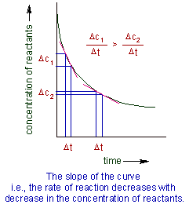
http://www.adichemistry.com/physical/kinetics/factors/factors-affecting-rate-reaction.html#CONCENTRATION-OF-REACTANTS

Pressure factor
The pressure factor increases the concentration of gases that in turn results in the increases of the rate of reaction. The rate of reaction increases in the direction of less gaseous molecules and decreases in the reverse reaction. Using that statement, it can be said that the pressure and concentration are interlinked and has a great impact on the rate of reaction.

Temperature
The collision theory is once again referred here as an explanation on how the temperature affects the rate of reaction. The chemical reaction that takes place at a higher temperature generates more energy than a reaction at a lower temperature. The reason for that is because of the colliding particles that will have the required activation energy at a high temperature and more successful collisions will occur. There are also few reactions that are independent of temperature, reactions without an activation barrier are independent of temperature.
According to the research done, the average kinetic energy increases with increase in absolute temperature. So, the number of molecules with an energy greater than the threshold energy will also increase. The result will be that the number of effective collisions between reactant molecules also increases. Therefore, according to observation, the rate of reaction increases with an increase in temperature. The graph below is a Maxwell distribution curves than explain this.
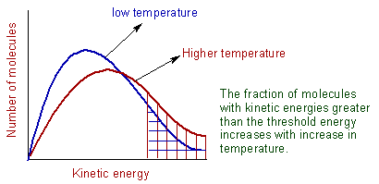
http://www.adichemistry.com/physical/kinetics/factors/factors-affecting-rate-reaction.html#CONCENTRATION-OF-REACTANTS
It is important to note that increase in temperature also increases the number of collisions and because of that the number of effective collisions will then increase. It is also known that the collision frequency is proportional to the square root of absolute temperature of the gas. An example of that can be if the temperature is increased by let’s say 10 °C from 290 K to 300 K, the collision frequency can then be increased by a factor of only 1.7 %. Usually the rate of reaction is doubled which means it is increased by 100% when the temperature is increased by 10 °C. Because of that the effect of collision frequency is minor on the rate of reaction. The major factor will be if there is a increase in the fraction of molecules that can cross the energy barrier at higher temperature.
The ratio of rate constant of a reaction at two different temperatures that differ by 10 °C is called temperature coefficient. The equation for that is stated below:
Temperature coefficient = ^{k}(t + 10)°C / ^{k}t°C = 2 to 3
The relation between rate constant and temperature can be shown by Arrhenius equation which is stated below:
K = A. e ^{-Ea/RT}
Where
K = specific rate constant
A = frequency factor
E_{a} = activation energy
R = gas constant
T = absolute temperature
So upon multiplying by ln which is the natural logarithm on both sides we will get,
Ln k = ln A – E_{a} / RT
2.30logk = 2.30log A – E_{a} / RT
Log k = log A – E_{a} / 2.30RT
For that reason, when a graph is for a log k against 1/T, there will be a straight line with negative slope,
Where the slope is = - E_{a} / 2.30 R
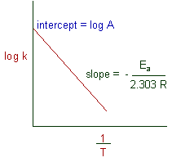
http://www.adichemistry.com/physical/kinetics/factors/factors-affecting-rate-reaction.html#CONCENTRATION-OF-REACTANTS
The relation between two rate constants such as k₁ and k₂, at two different temperatures which is T₁ and T₂ can be gives as:
Log k₂/k₁ = E_{a} / 2.30R (1/T₁ – 1/T₂) OR it can be gives as log k₂/k₁ = E_{a} (T₂ – T₁) / 2.30R T₁T₂
However, it is not always true that the rate of a reaction increases as the temperature increases, it is so that certain reactions such as biological reactions that are catalysed by enzymes may slow down as the temperature increases as the enzymes may lose their activity.

Electromagnetic radiation
Electromagnetic radiation is a form of energy and being present at a chemical reaction may increase the rate of reaction as it gives the particles of reactants with more energy. The intensity of light also affects the rate of reaction. The particles absorb more energy with the increase in the intensity of light so increasing the rate of reaction.

Presence of catalyst
A catalyst can be defined as a substance that increases the rate of the reaction without using itself up in the reaction. Using that definition, it says how it affects the chemical reactions. It is so that the catalyst increases the speed of a reaction in both forward and reverse reaction by giving another pathway with lower activation energy. It is so that a catalyst increases the rate of reaction by producing a new path with a lower activation energy (E_{a}) for the reaction. The diagram below states that definition:
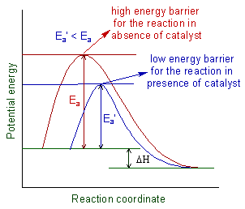
http://www.adichemistry.com/physical/kinetics/factors/factors-affecting-rate-reaction.html#CONCENTRATION-OF-REACTANTS
In a case of a reversible reactions, the catalyst lowers the activation energies of both forward and backward reactions to the same extent and it helps to attain the equilibrium very quickly. The diagram above is evident that when a catalyst increases the rate of forward reaction, it will also increase the rate of backward reaction. It is so that few substances may decrease the rate of reaction and are commonly referred as the negative catalysts or inhibitors. Their task is to interfere with the reaction by forming a relatively stable complexes that require more energy to breakup and so, the speed of the reaction is decreased.

The surface area of reactants
The surface area of reactants is another important factor to consider as it affects the rate of reaction greatly. If the size of a particle is small, then the surface area will be more, and, in that case, it will increase the speed of heterogeneous chemical reactions.

Rate of determining steps
The rate of determining step is the slowest step of a chemical reaction that determines the rate at which the overall reaction proceeds. A comparison to the rate of determining step is the neck of a funnel. The rate at which water flows through a funnel is determined by the width of the neck of the funnel and not by the speed of it being poured into the funnel. Like the neck of the funnel, the slow step of a reaction determines the rate of a reaction. It is so that not all the reactions have rate of determining steps but can have one only if one step is significant slower than the other steps in the reaction.
The rate determining step is important in deriving the rate equation of a chemical reaction, an example of that is the multi – step reaction.
A + B ----> C + DA + B ----> C + D
The elementary steps for this reaction are as the following:
Step 1: slow A + A C + EA + A C + E (with a rate constant, k1k1)
Step 2: fast E + B A + DE +B A + D (with a rate constant, k2k2)
In this case the E is an intermediate, the product in step 1 and a reactant in step 2 that is not visible in the overall reaction. This is due to when steps 1 and 2 are added, the intermediate E is cancelled out along with extra reactant A from step 1. It’s very important to recognise that the intermediate reactions do not show themselves in the overall reaction. In the case of this hypothetical reaction, if step 1 is the slow step and step 2 is the fast step of the reaction, then the overall reaction rate depends on step 1. It is so that the slow step in a reaction is always the rate – limiting step which is another name for the rate determining step.
So, for that reason the rate equation is:
Rate = k₁[A][A] = k₁ [A]² rate = k₁[A][A] = k₁[A]²
An example of reaction:
NO_{2 (g)} + CO _{(g)} NO_{(g)} + CO_{2 (g)} NO_{2 (g)} + CO _{(g)} NO _{(g)} + CO_{2 (g)}
This reaction occurs in two elementary steps:
NO₂ + NO₂ → NO + NO₃ (slow) NO₂ + NO₂ → NO + NO₃ (slow)
NO₃ + CO → NO₂ + CO₂ (fast) NO₃ + CO → NO₂ + CO₂ (fast)
Due to that the first step is the slowest step, the overall reaction cannot proceed any faster than the rate of the first elementary step. The first elementary step in the example above is therefore the rate – determining step. The rate equation for this reaction is equal to the rate constant of step 1 multiplied by the reactant of that first step. If the rate constant of step 1 I denoted k₁, then the rate of the first step in the reaction and the total reaction will then be:
Rate=k₂[NO₂] [NO₂]=k₁[NO₂]² rate=k₁[NO₂][NO₂]=k₁[NO₂]²

Methods
For this topic, plenty of methods can be used to determine the rates of reaction using different factors, below are three methods presented for the determination of rates of reactions using temperature, concentration and catalysts.

Method 1 – using temperature to determine the rate of reaction
Start with putting 10 cm³ of sodium thiosulfate solution and 40 cm³ of water into a conical flask. Then measure 5 cm³ of dilute hydrochloric acid in a small measuring cylinder. Then warm the thiosulfate solution in the flask If necessary to bring it to the required temperature. the object is to repeat the experiment five times with temperatures in the range of 15 – 55 °C. Put the conical flask over a piece of paper with a cross drawn on it. Then add the acid and start the clock, make sure to swirl the flask to mix the solutions and place it on a piece of paper of white marked with a cross, take the initial temperature of the mixture. Then look down at the cross from above. When the cross disappears make sure to stop the clock and note the time taken, record the final temperature of the mixture in the flask. As soon as possible, pour the solution down the sink (in the fume cupboard if possible) and wash it away.

Method 2 – using concentration to determine the rate of reaction
Start with putting 50 cm³ of sodium thiosulfate solution in a flask then measure 5 cm³ of dilute hydrochloric acid in a small measuring cylinder. Then add the acid to the flask and immediately start the clock, swirl the flask to mix the solutions and place it on a piece of paper marked with a cross. Then look down at the cross from above. When the cross disappears stop the clock and note the time. Record this in the table. Repeat this using different concentrations of sodium thiosulfate solution. Make up 50 cm³ of each solution, mix different volume of the sodium thiosulfate solution with water as shown in the table. As soon as possible, pour the solution down the sink and wash it away immediately.

Method 3 – using different concentration to determine the rates of reaction
start the practical by first collecting all the required equipment and chemicals for the experiment, then straight after set-up the practical. then transfer 20 ml of 0.5 M of HCL to a measuring cylinder using a calibrated, washed and cleaned pipette. then pour that into a 50 ml conical flask, make sure to clean all the glassware equipment to prevent any contamination. Then, cut 2 cm of magnesium ribbon strip and transferred that into the conical flask with 20 ml of HCL (0.5 M) in it. Straight after that immediately attach the gas syringe to the conical flask by using rubber tubing connection and a rubber bung. The magnesium ribbon would already have started to dissolve, and hydrogen gas being released, make sure to measure the amount of the hydrogen gas produced and to start the stop watch at the same time to get an accurate reading. Repeat the step 4 times to get an accurate average of the result. Then repeat the same procedures 4 times with different concentration of HCL (1.0, 1.5, 2.0 M).

Method 4 – using catalysts to determine the rate of reaction
Start with putting a few pieces of granulated zinc into each of the three test tubes. Try to have approximately the same amount in each test tube. Then add 5 cm³ of dilute sulfuric acid to test tube 1. Note the rate of production of gas bubbles. Add a few copper turnings to test tubes 2. Make sure they are in contact with the zinc. Then add 5 cm³ dilute sulfuric acid and note the rate of production of gas bubbles. Then add 5 cm³ of dilute sulfuric acid to test tube 3. Then add about 1 cm³ of the copper sulfate solution using a dropping pipette, note the rate of production of gas bubbles. Note what happens to the color of the copper sulphate solution, also note what happens to the surface of the pieces of zinc.
Each of the methods are derived from the website http://www.rsc.org/learn-chemistry/resource/listing?searchtext=factors%20affecting%20the%20rate%20of%20reaction and the methods can be used to determine the rates of reaction using the right chemicals and equipment.

Review of research
Plenty of sources was used to be able to do a proper research on the specific area that I have chosen to investigate. The factors that determines the rates of reaction are many. According to Chang, R. (2004). Physical chemistry for the biosciences. Sausalito. Ca: University science books, the rate of determining steps plays a great role to be able to determine the speed or the rate at which the overall reactions proceeds. This gives us a good glimpse on how rate determining step works as it is the slowest step of a chemical reaction. The rate of determining steps which is simplified into rate equation and multi – step reaction by Hahn, H.H. & Stumm, W. (1968). Kinetics of coagulation with hydrolysed Al (III): the rate of determining step. Journal of colloid and interface science. 28, 134-144. Makes it easier for us to understand how the rate of determining steps works.
According to the expert of the website http://www.adichemistry.com/physical/kinetics/factors/factors-affecting-rate-reaction.html#CONCENTRATION-OF-REACTANTS the factors that affect the rate of reaction such as the concentration, temperature, pressure, catalysts etc, plays a great role on how the reaction is speeded up. As evidence, diagram and equation are provided and makes it easier to understand their impact on the rate of reaction which leads to how they determine the rates of reaction. Each one of the factors can be used to put forth a practical investigation that can be carried out to be able to determine the rates of reaction of a certain chemical reaction between two substances.
Using the information from the website https://www.britannica.com/science/collision-theory-chemistry, it was possible to extract details about the collision theory that is part of the research (scroll up). All the factors as stated above are linked to collision theory as it is defined by its name. The collision theory is all about the collision of molecules and how the factors such as temperature and concentration etc influence the molecules. According to the expert on the website the collision of the molecules is proportional to the increase of temperature or concentration. This makes it also easier to understand how the factors plays a great role on determining the rates of reaction as they are very similar to definition, to increase the factors in its special form will increase the effectiveness of collision of molecules onto another that will lead to an increase in the rate of reaction.
The different methods that could be used for the project investigation practical are being used by many schools and colleges, of course the schools and colleges are limited to the size of production and equipment but in industrial scales the methods are processed during a longer term such as days, weeks and sometimes months end up with a maximal yield.

General conclusion
Conclusion 1:
Using the project research for extracting as much as information about the factors that determines the rates of reaction was not an easy job. A lot of the resources were old and not a lot of new discoveries were made to be included as a case study, even though that the factors that determines the rates of reaction has a great importance and influence in industrial scale for making different products such as medicine for example.
Conclusion 2:
The beneficial part of the rate of reactions is that it helps the industries to maximise their yield within a given time frame using the factors that affects them. A lot of costs and risks are being put into this to maximise a profit for the industries. The rate of determining steps brings a detail information on how to be able to determine what kind of reaction it is, slow or fast. The rate determining step is the slowest step of a chemical reaction that determines the rate at which the overall reaction proceeds, using that information the industrial chemists can work around that and speed up the reaction by either adding a catalytical substances or the use of another factor to speed up the reaction.
Conclusion 3:
Having a hypothesis on my mind during the research, it was hard to put it to a ‘if’ and ‘then’ sentence as a lot of information was extracted from different sources during the literature research. It can be concluded that the research and the review went according to how I expected to be and that the factors that affect the rate of reaction is not just a part of the chemistry science, rather it has it many uses in other scientifically fields and in our daily life routines.

Conclusion
Bring it all together for a final conclusion, I have had a deep glimpse on how important the factors that determines the rates of reaction are. The factors such as temperature, concentration, pressure, catalysts etc, are linked up to the collision theory that simplifies the understanding of how them all are connected, using the rate of determining steps to identify the slowest chemical reaction and how that determines the overall rate of reaction proceeded is amazing. I would like to say that there are points in where I had my doubts on the reliability of the sources I was using but when it came forth with evidence such as diagram and mathematical equation that put an ease on my mind. It made me feel comfortable to say that I agree with the sources I used for my research. I also believe I could have done more research about the factors and deepen myself into this topic to improve and increase my knowledge for this topic.

Investigative project proposal
I have chosen to investigate the effect of increased concentration of hydrochloric acid on the magnesium ribbon. I will be using a stop watch to time the magnesium ribbon until it dissolves in hydrochloric acid that will be in different concentration.
The main reasons to why I choose this topic which a chemistry subject is that I found it easy to follow and understand, and if I find something that is easy for me to understand I will deepen my knowledge in that. If I can understand something very easily then I can as well preserve it in my memory and mind. Not only that I have always found chemistry subjects easy to follow and of course their different levels of advancement in chemistry but by learning the basis and building it up from there I can consume myself with great knowledge. Chemistry has always been my favourite science subject as well and that is also one of the reason to why I choose this topic.
I am expecting to gain a deeper knowledge of factors that determines the rates of reaction, I want to understand how they work in industrial scales and compare that to schools and colleges. I already know that there will be a huge difference as I have previously read about in a chemistry book, but I want to put myself into practical and investigate this a bit further.

Hypothesis
Hypothesis 1
If there is an increase in concentration in hydrochloric acid, then the magnesium ribbon will dissolve quicker and there will be an increase in rate of reaction.
Hypothesis 2
If the temperature of the hydrochloric solution increases it will cause the magnesium ribbon to dissolve in a greater speed and there will be an increase in rate of reaction.

Null hypothesis
Null hypothesis 1
The increase in rate of reaction is not proportional to the increase in concentration of the hydrochloric acid.
Null hypothesis 2
An increase in temperature of the hydrochloric acid solution is unrelated to the increase in rates of reaction.

Aim and objectives
Aim 1:
To be able to calculate the rate of reaction by increasing the concentration of hydrochloric acid and measuring the volume of hydrogen gas that is released during the reaction between the reactants.
Aim 2:
To be able to calculate the rates of reaction for the compound magnesium that is determined by the increase in temperature for the hydrochloric acid solution for a given time period and explain the relationship between them.
Objectives 1
To collect data on the amount of hydrogen gas volume being evaporated through a gas cylinder, and to time it until the magnesium is fully dissolved in the acid. To also calculate the rates of reaction for the different hydrochloric acid concentration being used.
Objectives 2
To collect data on how increasing the temperature for the hydrochloric acid solution will affect the rate of the magnesium ribbon being dissolved. There should be a table of different temperature being used and the time It took for the metal to dissolve fully, to be able to identify the trend.

Potential limitations
It is always important as a scientist and science researcher to consider their limitations of a projective investigation before they plan it and put it to practical. Some of the factors that are involved in this are the resources being used, the use of facilities and the time constraints.
As part of investigation, I have put forth a list of things I need and handed it over to the technicians before the date of my practical investigation. This gives both me and the technicians enough time to consider the resources available for the practical investigation to take place. The list included the chemicals and their amount for which is required for the practical work to go well. I also included the equipment which I will need on the day of the experiment.
It is important to also consider the place that the practical investigation is going to take place, due to the limitations of resources, the investigation I’m going to do will be in a college laboratory which can affect the practical depending on the design of the laboratory. Some are designed in for chemistry and some for other type of scientific fields. So, for this reason a well-planned investigation is required, not only that but a back – up plan is also good to have in hand if anything would not go as planned.
The time constraint is a very important factor as being limited to time can end up with a unfinished practical leaving a lot empty gaps in the practical write up after the practical investigation. Due to that, I agreed with my tutor that I needed the laboratory for at least 4 hours just in case my first plan of the investigation doesn’t go as planned and that I need to use my backup plan as a safety exit.

Assignment B – Project investigation plan
In this assignment I will produce a realistic working plan for the project that includes health and safety risk assessments. I will also produce a realistic working plan for the project that includes health and safety risk assessments and contingency planning. Finally, I will analyse the effectiveness of the working plan and justifying the changes made.

Schedule
This practical investigation will start and end on the:
03/04/2018 in Barking and Dagenham college laboratory
Start time: 10.00 am
Break time: 12.20 – 13.00
End time: 3.00 pm
Duration: 4 hours and 20 min

Plan

Aim
To be able to calculate the rate of reaction by increasing the concentration of hydrochloric acid and measuring the volume of hydrogen gas that is released during the reaction between the reactants.

Objectives
To collect data on the amount of hydrogen gas volume being evaporated through a gas cylinder, and to time it until the magnesium is fully dissolved in the acid. To also calculate the rates of reaction for the different hydrochloric acid concentration being used.

Hypothesis
Based on the literature research on the collision theory, it can be stated that as the concentration of hydrochloric acid solution increases (which means that the number of hydrogen and chloride ions increase), the chances of magnesium particles colliding with the hydrochloric acid particles at a given time period also increase. So, the hypothesis will be that, the higher the concentration of hydrochloric acid, the higher the rate of hydrogen gas produced.

Null hypothesis
The increase in rate of reaction is not proportional to the increase in concentration of the hydrochloric acid.

Variables
- Dependant variable – volume of hydrogen gas, and rate of reaction
- Independent variable – concentration of HCL solution
- Control variable – length of magnesium ribbon, size of the test tube, volume of hydrochloric acid solution used and temperature of reactants.

Apparatus
- Gas syringe
- Conical flask (100 cm³)
- Clamp stand with a boss and clamp
- Stop watch
- Rubber band (approx. 30 – 40 cm long)
Chemicals
- Diluted hydrochloric acid in 4 different concentrations (0.5, 1.0, 1.5 and 2.0)
- Magnesium ribbon cut into 3 cm (6-10 pieces)
- De – ionized water

Method
- Start with gathering all the required equipment and chemicals for the experiment, then set up the apparatus shown on the diagram below.
- Use a pipette and a pipette filler to transfer 20 ml of 0.5 M HCl to a measuring cylinder and then pour that into a 50 ml conical flask (makes sure to clean conical flask with de – ionized water before use to prevent any random results).
- Cut 3 cm of magnesium ribbon strip and then transfer that into the conical flask with 20 ml HCl in it.
- Immediately attach the gas syringe to the conical flask by using rubber tubing connection and a rubber bung.
- The magnesium ribbon would already have started to dissolve and hydrogen gas being released, measure the amount of hydrogen gas produced and also make sure to start the stop watch at the same time to get an accurate reading.
- Repeat step 2-5, 4 times and repeat that with the 3 other concentration of HCL (1.0, 1.5 and 2.0)
Practical set-up
Using the apparatus listed above the set – up of the experiment is visualized below.

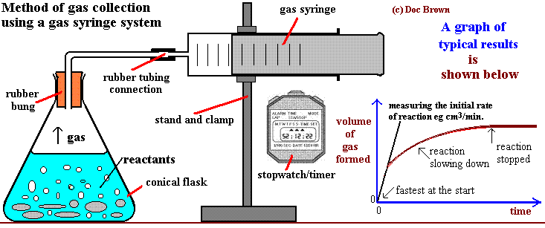
https://sites.google.com/site/internationalgcsechemistry/year-10-topics/rates-of-reaction/finding-a-rate-of-reaction
Health and safety
- During the practical, acids of high molarity will be used so it is very important to take great care when handling them. This prevents any injuries or incidents to occur to put both yourself and people around you in danger.
- Try to avoid consuming anything such as food or drink except water. This also reduces the risk of any harmful chemicals be mixed with the drink or the food.
- Always wear proper PPE (Personal Protective Equipment) such as lab coat, spectacles and gloves to protect yourself from any danger during the practical.
- Handle the glassware with great care as it can be very slippery as it can get in contact with the de-ionized water and that using gloves to try to grip them can easily slip off the fingers and break. This can also lead to cuts and cause bleeding.

Risk assessment

Equipment / chemical hazard | Risk | Prevention | Treatment
Diluted hydrochloric ribbon | Corrosive depending on the concentration, can cause great damage to both eyes and skin | Wear proper laboratory gear such as lab coat, googles and gloves | Quickly wash the affected area with plenty of water, use the eye wash if it comes in contact with the eyes. Seek medical help if the case is serious
Magnesium ribbon | Burns vigorously with high concentration of hydrochloric acid, can easily splash unto the skin and eyes and cause great damage | Make sure to be fully protected by following PPE instruction and make sure to drop the Mg ribbon in a safe environment and keep a distance from it while doing that | Wash the affected area with plenty of water and seek medical help if the case is serious
Glassware | Can cause cuts that leads to bleeding if it breaks | Handle with care using the right technique and always wear PPE | Use bandages to stop the bleeding and plaster it depending on the size of the cut, seek medical help if the cut is deeper and bigger and if the casualty loses a lot of blood then an ambulance must be called

Contingency planning
The contingency planning will be there as back – up plan if anything would not go as planned. So, as a back – plan I have chosen to use temperature instead of concentration to investigate how the temperature will affect the rate of the solution being dissolved.

Apparatus
- Sodium thiosulfate solution 40 g dm⁻³
- Hydrochloric acid 2.0 moldm⁻³ (corrosive)
- Distilled water
- 250 cm³ conical flask (2 of them)
- Measuring cylinder (10 cm³)
- 50 cm³ measuring cylinder
- Bunsen burner
- Tripod
- Thermometer
- Stop watch

Method
- Put 10 cm³ of sodium thiosulfate solution and 40 cm³ of distilled water into a conical flask. Measure 5 cm³ of dilute hydrochloric acid in a small measuring cylinder.
- Warm the thiosulfate solution in the flask if necessary to bring it to the required temperature. The object is to repeat the experiment five times with temperatures in the range 15–55 °C.
- Put the conical flask over a piece of paper with a cross drawn on it.
- Add the acid and start the clock. Swirl the flask to mix the solutions and place it on a piece of white paper marked with a cross. Take the initial temperature of the mixture.
- Look down at the cross from above. When the cross disappears, stop the clock and note the time taken. Record the final temperature of the mixture in the flask. As soon as possible, pour the solution down the sink (in the fume cupboard if possible) and wash away.

Result table
Trials 1-5 | Initial temperature of the mixture in the flask/°C | Final temperature of the mixture in the flask/°C | Average temperature of the mixture in the flask/°C | Time taken for the cross to disappear/s | 1/time taken/s
1
2
3
4
5

Health and safety
- Wear eye protection. Sulphur dioxide (Toxic gas) forms as a by-product.
- Ensure good ventilation. If there are asthmatics in the class, the risk assessment should take this into account and necessary adjustments made, such as working in a fume cupboard, reducing the scale etc
- As soon as the reaction is complete pour the solutions away, preferably into the fume cupboard sink. Wash away with plenty of water. This is particularly important with solutions used at higher temperatures.

Risk assessment
Equipment / chemical hazards | Risks | Prevention | Treatment
Sodium thiosulfate | Fire and explosion can cause burns and redness in the eyes if exposed to it for a long time | No eating, drinking and avoid inhaling it during the practical work. Make sure to avoid contact with oxidants and always wear googles and proper lab gear. | Rinse the affected area with plenty of water and call the fire fighters and ambulance if the case is very dangerous.
Hydrochloric acid 2 M | Very corrosive as the concentration of it being used is high and can cause severe burns and corrosion on the skin and eye | Always be properly geared up wearing lab coat, googles and gloves to avoid any incidents to take place | Rinse the affected area with plenty of water and seek medical assistance if needed.
Bunsen Buner | Causes severe burns and damages | Wear proper lab kit such as lab coat, gloves and googles and handle with great care, always make sure to put the safety flame (yellow flame) when it is not being used. | Wash the affected area with plenty of cold water and seek medical assistance if the case is very dangerous
Glassware | Cause cuts and bleeding if its breaks, also burn you if it has been stood over Bunsen burner for a long time | Take extra care using the glassware especially the beakers as they will be very hot as being stood over the Bunsen burner. Wear gloves and lab coat and googles to prevent any injuries and incidents. | Use the first aid kit and wash the cut and use a plaster or bandage to stop the bleeding, seek medical assistance if the bleeding doesn’t stop and call the ambulance.

Ethical considerations
The ethical considerations for the science investigation in a school, college or sixth forms are limited so it will be of high difficulty to produce an opinion in this. It is so that the ethics are concerned with the essential rights and wrongs or moral principles of a person behaviour and in science this issue becomes more important in many forms. Few examples can be:
- Using live animals such as daphnia in caffeine solution
- The effect on the ecosystem where live samples are taken
- Or using people for timed experiments after stimulants are used to determine change in reflexes
There are many other forms but again there is a limitation to this. An example of that can be that if someone has intended to use other people for the sake of their scientifically investigation it is of highly importance to ask for their consent, to give them a clear and good explanation of the investigation and that they are agreed upon. It is important to inform the individual of their rights when asking for their consent. To inform them of the purpose of the investigation, what procedures will be carried out and what the data will be used for, the possible risks involved and the potential benefits of the study. The last part will be to make sure that the confidentiality of information must be ensured in the investigation, making sure that important and personal information on health issues or other personal aspects are not divulged to persons without the permission of the individual that is concerned in the investigation.
For the practical work that I am going to investigate does not include such an ethical consideration as it will take place in a college laboratory. However, the way I carry out the practical using harmful chemicals can play a great role on the importance in health and safety topic. I need to identify the equipment and the substances that I will be using for the practical investigation, do a detail investigation on their hazards and the potential risks which I have done on the risk assessment part. This will increase the chance of the environmental safety in where I am going to do my investigation.

Unit 6 – investigative project, Assignment C and D

Project implementation and review
In this assignment I will demonstrate practical skills to assemble relevant apparatus/equipment and materials and carry out the project using safe working practises. I will also accurately collect, analyse and present the results obtained. Then I will justify the choice of experimental and data analysis techniques used as means of increasing accuracy, reliability and validity. After than I will produce a report using findings, scientific terminology and protocol appropriately and drawing conclusions. I will summarise the skills I developed in the investigate project that I undertook. I will then discuss the importance of the skills that I developed in the investigative project undertaken to achieve the required aims. Lastly, I will evaluate the conclusion of the investigative project and its practical aspects, discussing limitations, improvements and recommendation for further study. Also, I will evaluate the skills developed in the investigate project undertaken and suggest areas for improvement.

Collection, analysis and presentation of the results
The practical investigation started with me setting up the apparatus and the chemical I needed, it can be shown on the image below which was taken during the experiment. I made sure to name each of the beakers with the substances I was using to prevent any mixing and confusion to avoid any anomalous to occur.
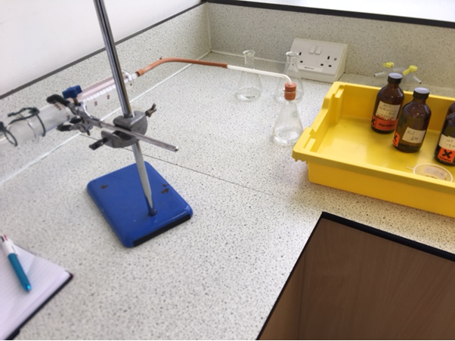
Picture was taken during the experiment of the factors affecting the rate of reaction, here is a visible set-up of the practical.

Before I started fully with experiment and that it was already checked by the tutor, I made sure to revisit my risk assessment of the equipment and the chemicals I was about to use to ensure the safety of myself and the people around me as well.

Report of the investigative project

Title
The effect of different hydrochloric acid concentration on the rate of magnesium ribbon being dissolved

Abstract
The purpose of the investigation was to explain, discuss and evaluate the effect of hydrochloric acid on magnesium ribbon using different concentration. To be able to complete the experiment using the results and calculating the rate of reaction of the different concentration of the hydrochloric acid on the magnesium ribbon. The use of the rate determining steps to explain the reaction between them and finding the trend by drawing a line graph of the result attained from the practical work.

Introduction
The four main factors such as concentration, temperature, surface area of reactant and catalysts are the ones that has a great impact on the rate of reaction. In this experiment the reaction between hydrochloric acid solution and magnesium ribbon is investigated as the concentration of the hydrochloric will be increased.
2HCl _{(aq)} + Mg _{(s)} ---------------> MgCl₂ + H_{2 (g)}
The rate of reaction can be calculated by measuring the speed at which reactants are consumed or at the speed which products are formed. In this case there will be a production of hydrogen gas which means the rate of reaction can be calculated by using the volumes of hydrogen gas formed until the reactants are consumed and the time it took for consumption. A line graph can be drawn by using the rate of reaction which can be calculated (R = V / t) against the concentration of hydrochloric acid solutions.

Method
I Start with gathering all the required equipment and chemicals for the experiment, then I set up the apparatus according to the diagram on the planning bit. Then I used a pipette and a pipette filler to transfer 20 ml of 0.5 M HCl to a measuring cylinder and then poured that into a 50 ml conical flask (making sure to clean the conical flask with de – ionized water before use to prevent any random results). After that I cut 3 cm of magnesium ribbon strip and then transferred that into the conical flask with 20 ml HCl in it. Immediately after that I attached the gas syringe to the conical flask by using rubber tubing connection and a rubber bung. The magnesium ribbon would already have started to dissolve, and hydrogen gas being released, I made sure to measure the amount of hydrogen gas produced and also making sure to start the stop watch at the same time to get an accurate reading. I then Repeated step 2-5, 4 times and did that with the 3 other concentration of HCL (1.0, 1.5 and 2.0)

Results
Quantity data
Hydrochloric acid concentration / Molarity | TRIAL  (GAS)  V₁ (ml) | 1  t₁ (s) | TRIAL  (GAS)  V₂ | 2  t₂ (s) | TRIAL  (GAS)  V₃ | 3  t₃ (s) | TRIAL  (GAS)  V₄ (ml) | 4  t₄ (s) | AVERAGE  (GAS)  V_{A} (ml) | AVERAGE  (GAS)  t_{A} (s)
0.5 | 5 | 400 | 4 | 350 | 5 | 410 | 5 | 375 | 4.75 | 384
1.0 | 6 | 250 | 9 | 235 | 7 | 240 | 7 | 265 | 7.25 | 247
1.5 | 17 | 45 | 17 | 50 | 18 | 55 | 17 | 43 | 17.25 | 48.0
2.0 | 18 | 25 | 21 | 30 | 20 | 27 | 21 | 26 | 20.00 | 27.0
Table 1 : change in volume of hydrogen gas released over time at different hydrochloric acid concentrations
Hydrochloric acid concentration / molarity | Rate of reaction = V / t
Hydrochloric acid concentration / molarity | Trial 1 | Trial 2 | Trial 3 | Trial 4 | Average | Standard deviation
0.5 | 5/400=0.0125 | 4/350=0.0114 | 5/410=0.0122 | 5/375=0.0133 | 0.0124 | 0.001057
1.0 | 6/250=0.0240 | 9/235=0.0380 | 7/240=0.0290 | 7/265=0.0260 | 0.0293 | 0.005355
1.5 | 17/45=0.378 | 17/50=0.340 | 18/55=0.330 | 17/43=0.400 | 0.362 | 0.028320
2.0 | 18/25=0.720 | 21/30=0.700 | 20/27=0.740 | 21/26=0.810 | 0.743 | 0.041460
Table 2: rate of reaction for each trial done at different hydrochloric acid concentration
Qualitative data
- Hydrochloric acid was colourless
- Reactions became more vigorous as the concentration of the hydrochloric acid increased
- The magnesium ribbon turned to a shiny silver colour after it was cleaned with sand paper
Rate determining step
Mg _{(s)} + 2 HCl _{(aq)} MgCl_{2 (aq)} + H_{2 (g)}
Step 1: Mg + Mg MgCl₂ + Mg (slow reaction)
Step 2: Mg + HCl Mg + H₂ (fast reaction)
H⁺ + Mg H + Mg⁺
H⁺ + Mg⁺ H + Mg²⁺
2 (H + H) H₂
This will be cancelled down to:
2H + Mg H₂ + Mg²⁺

Graphs
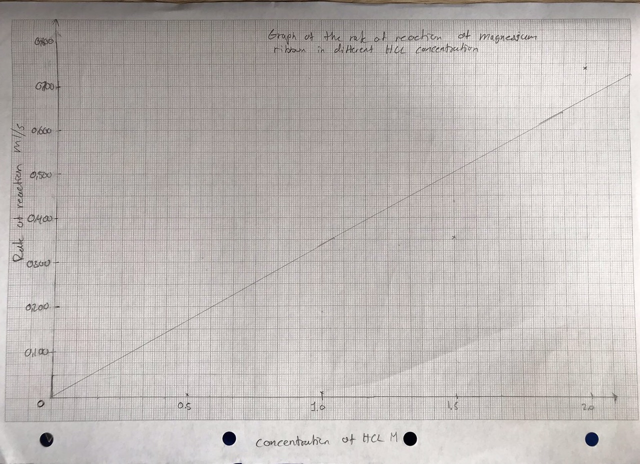
Graph 1: best line of fit graph of the average rate of reaction against the concentration of hydrochloric acid solutions
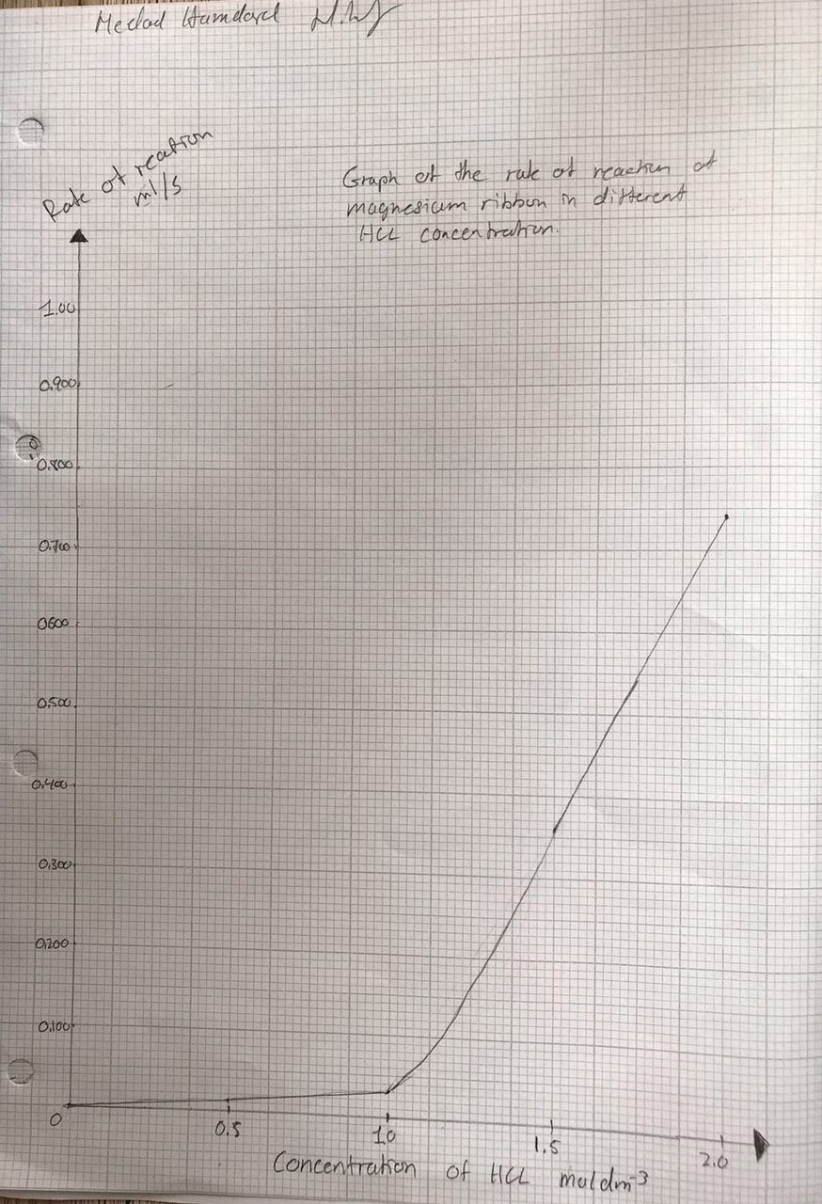
Graph 2: curve graph of the average rate of reaction against the hydrochloric acid solutions

Uncertainties
Standard deviation calculation:
[HCL] = 0.5 M
$σ=\sqrt{\frac{(0.0124}{}\frac{-0.0.125)^{2}}{}\frac{+ (0.0124-0.0114)^{2}+(0.0124-0.0122)^{2}+(0.0124-0.0133)^{2}}{4}}$ = 0.001057
[HCL] = 1.0 M
$$σ=\frac{\sqrt{{\left(0.0293-0.0240\right)}^{2}+(0.0293-0.0380)^{2}+(0.0293-0.0290)^{2}+(0.0293-0.0260)^{2}}}{4}=0.005355$$
[HCL] = 1.5 M
$$σ=\frac{\sqrt{{\left(0.362-0.378\right)}^{2}+(0.362-0.340)^{2}+(0.362-0.330)^{2}+(0.362-0.400)^{2}}}{4}=0.028320$$
[HCL] = 2.0 M
$$σ=\frac{\sqrt{{(0.743-0.720)}^{2}+(0.743-0.700)^{2}+(0.743-0.740)^{2}+(0.743-0.810)^{2}}}{4}=0.041460$$

Accuracy
Accuracy in the method was ensured by correcting every small detail that can change the accuracy of the results. The method had been earlier researched in detail and been tested before the actual investigation to avoid errors occurring during the practical work. Measurements were repeated up to four times to increase the accuracy of the results obtained from the practical work. The equipment was as well properly washed, cleaned and dried to avoid any contamination of the compound mixtures that could have caused many anomalous results.

Discussion
The aim of this investigation was to be able to calculate the rate of reaction by increasing the concentration of hydrochloric acid and measuring the volume of hydrogen gas that is released during the reaction between the reactants. The objectives were to collect data on the amount of hydrogen gas volume being evaporated through a gas cylinder, and to time it until the magnesium is fully dissolved in the acid. To also calculate the rates of reaction for the different hydrochloric acid concentration being used. Both the aim and objectives were achieved through the results gained.
The results were presented both in tables, calculation and graphs. The rate of reaction was calculated by using the volume of hydrogen gas being released and divided it by the time it took for the magnesium ribbon dissolve (e.g. R = V / t, for 0.5 M first trial; 5/400=0.0125). There were four trials for each concentration as four different concentration were used. An average of the rate of reaction was taken to increase the accuracy of the results. The graph shows the relationship between the rate of reaction and the concentration of hydrochloric acid solution.
Fortunately, there were no problems that occurred due to good planning of the practical work and good handling of equipment and as well of good observations. A small error that might have occurred would have been to notice the point when the magnesium ribbon was fully dissolved and stopping the time to avoid any anomalous results. An improvement for that would be to put a white paper beneath the beaker to observe the exact point at which the magnesium ribbon is fully dissolved and there is no hydrogen gas being evaporated.

Conclusions
The relationship between the rate of reaction and the concentration of hydrochloric acid solution can be seen by the two graph that was drawn above. The line graph shows a positive correlation between the rate of reaction and the concentration of the hydrochloric acid solutions, which means that the rate of reaction is directly proportional to the concentration of the reactants as the concentration increases for the hydrochloric acid. This indicates that the hypothesis is then confirmed and valid.

Scientific evaluation
The hypothesis of the investigation was that the higher the concentration of hydrochloric acid, the higher the rate of hydrogen gas produced. The null hypothesis was that, the increase in rate of reaction is not proportional to the increase in concentration of hydrochloric acid. In this case the null hypothesis was proved wrong and the hypothesis was valid. Using the literature search on the collision theory and by planning, undertaking the project investigation of the factors determining the rates of reaction it can be said that the increase of concentration will increase the chance of collision between the reactant particles and will therefore increase the rate of reaction. The results obtained from the practical work, calculation done for the rate of reaction confirms that statement. Although there is weak correlation as the point are not so close to the best line of fit, the curve graph shows the positive correlation of the two variables that was used (rate of reaction and concentration). The results gained from the findings of the investigation proved that with an increase in concentration there will be an increase in rate of reaction. This is supported by the graphs that shows the positive correlation between the rate of reaction and the hydrochloric acid solutions.
The standard deviation was as well calculated to express the difference of the results attained from the mean. This was done to see the accuracy of the results gained from the practical work. Yet again, as mentioned before the results support the hypothesis. Due to correct following of the method and handling the chemicals and the equipment the results obtained from the practical work confirmed the purpose of this investigation.
Another aspect was the use of the rate determining steps that puts the reaction into multi step reactions, fast and slow.
Mg _{(s)} + 2 HCl _{(aq)} MgCl_{2 (aq)} + H_{2 (g)}
Step 1: Mg + Mg MgCl₂ + Mg (slow reaction)
Step 2: Mg + HCl Mg + H₂ (fast reaction)
H⁺ + Mg H + Mg⁺
H⁺ + Mg⁺ H + Mg²⁺
2 (H + H) H₂
This will be cancelled down to:
2H + Mg H₂ + Mg²⁺
As it can be seen the multi – step reaction shows how the reactants react with each other and that step 1 is slower than step 2 in reaction.
During the practical work there were no major errors that was identified as practical ended up successfully, only that the reason to why there was a weak correlation would have been due to the experimental error that might been the reason, notification of the exact point when the magnesium ribbon being fully dissolved. It was difficult to observe the magnesium being fully dissolved but as the concentration increased the reaction was more vigorous, especially when it reacted in 2.0 M hydrochloric acid which is extremely corrosive. The reaction took less than few seconds to occur and to stop the time at the exact point could have been the reason to why there was a weak correlation. Another experimental error could have been the size of the magnesium ribbon, some pieces might have been larger or smaller than 3 cm which could have a great impact on the reaction time that will then be later used to calculate the rate of reaction.
Improvements would then be to make sure that the control variables stay the same, such as making sure the size of the magnesium ribbon is precisely 3 cm or whatever size that it might be, as long it remains the same. Another improvement would be to use a type of paper and place it beneath the beaker to exactly identify the fully dissolved magnesium ribbon to make sure the time is stopped at the right time. These improvements can increase the accuracy of the results and increase the reliability of the results gained.
Yet of course there is a limitation to the resources being used as the practical work was done in a college laboratory, while the experiments done in a bigger scale requires proper managements and use of machinery equipment’s that puts the results into precision. There is nothing such as the perfect experiment and there is always a need of repetition of investigation to increase the reliability of the information and results gained.

Skills developed within project work
During this investigation I learned a lot, not just in an informative way but also how to proceed with a project investigation. I learned how important it is to make sure the literature search is done appropriately as it will then help to put forth a proposal investigation plan which helped me a lot to plan for my practical work for the investigation. I made sure to take full responsibility of the work I was carrying out such as planning ahead of the time given to me, to make sure I don’t miss out anything when it comes to summarise the work. Not only that, but my time management was accurate as I was able to finish the experiment before the planned time which then allowed me to go through the practical work at the end and see if I have missed anything and try find the relationship between the two variables.
Another important aspect was that I always maintained my attitude in a mature and professional way no matter what, this helped me to maintain full focus on the practical work that I carried out which then lead to be successful as stated earlier. I got several feedbacks from my tutor for some improvements and I used that to increase and improve the reliability of the experiment. I always ensured to stick to the standards and protocols so that I don’t get lost when carrying out the project investigation.
This project work helped me a lot to understand that there is always space for improvements, it doesn’t matter how perfect an individual as there is actually none but that aiming for perfection is something that is not bad. Even though not being perfect, the skills learned and developed puts you in a path to something great that will be beneficial for both you and the people around you. The skilled I learned within the project work will also help me in future to achieve my goals and aim in life.

Reference
https://www.thoughtco.com/factors-that-effect-chemical-reaction-rate-609200
https://chem.libretexts.org/Core/Physical_and_Theoretical_Chemistry/Kinetics/Reaction_Rates/Factors_That_Affect_Reaction_Rates
http://www.rsc.org/learn-chemistry/resource/listing?searchtext=factors%20affecting%20the%20rate%20of%20reaction
http://www.rsc.org/learn-chemistry/resource/res00001916/the-rate-of-reaction-of-magnesium-with-hydrochloric-acid
http://en.wikibooks.org/wiki/Structural_Biochemistry/Enzyme/Rate-limiting_step
https://www.slideshare.net/wkkok1957/rate-of-reaction-between-magnesium-and-hydrochoric-acid-using-pressure-sensor
https://sites.google.com/site/internationalgcsechemistry/year-10-topics/rates-of-reaction/finding-a-rate-of-reaction
http://www.adichemistry.com/physical/kinetics/factors/factors-affecting-rate-reaction.html#CONCENTRATION-OF-REACTANTS
http://nobel.scas.bcit.ca/wiki/index.php/Methods_of_measuring_reaction_rates

